WEEK 12
Week Ending: |  | Day: |  | Subject: Career Technology
Duration: 60MINS |  |  |  | Strand: Materials For Production
Class: B8 |  | Class Size: |  | Sub Strand: Food Commodities
Content Standard:  B8.2.4.1 Demonstrate understanding of the functions of food commodities |  |  | Indicator:  B8.2.4.1.1: Explore the functions of food to the body. |  |  |  | Lesson:  1 of 2
Performance Indicator:  Learners can explore the functions of food to the body |  |  |  |  | Core Competencies:  CP 6.5: CI 5.4: CI 5.2:
Reference: Career Technology Curriculum Pg. 50
Phase/Duration | Learners Activities |  |  |  |  | Resources
PHASE 1: STARTER | Bring food items to the class and display them on the teachers table.  Call learners in turns to identify the names of the food items.  Let learners relate to the items and tell their uses.  Share performance indicators and introduce the lesson.
PHASE 2: NEW LEARNING | Revise with learners the meaning of food.  Food is described as anything solid or liquid which when taken in can be digested and absorbed by the body to:  1. Provide heat and energy.  2. Promote growth.  3. Protect the body against diseases.  4. Regulate body processes (e.g. roughage in food helps bowel movement and prevents constipation).  Guide learners to classify foods according to their basic functions.  1. Body building foods or Grow foods: examples are animal food such as eggs, meat, fish, and plant food like the pulses (beans, agushice, etc).  2. Energy giving foods or Go foods: examples are cereals and grains such as maize, rice, millet, etc. fats and oils like margarine, palm oil, butter, etc. and root tubers such as yam, cassava, cocoyam, etc.  3. Protective foods or Glow foods: examples are fruits and vegetables such as orange, banana, pawpaw, tomato, kontomire, garden eggs, pepper, etc.  Brainstorm learners to talk about the importance of the three food groups.  - It is important to know which food does what work in the body so that you can eat the right kinds of foods to stay healthy.  Guide learners relate food commodities to their functions.  Body building foods  Group 1:  Animal foods and their products  Some examples include: snails, fish, eggs, meat, milk, etc. Nutrients: protein (animal protein or first class protein).  Group 2:  Legumes and oily seeds  Some examples include: pulse (beans of all kinds e.g. Bambara beans, peas, soya beans, etc. others are ground nuts, cashew nuts, melon seeds (agushie), etc.  Nutrients: protein (vegetable protein or second class protein), mixed elements like calcium, iron, etc  Functions of proteins:  • It builds the body  • It repairs worn out cells and tissues.  Assessment  - What is food?  - State with three examples each, the six food groups.  - Mention four importance of eating food.  - Body building foods or growth foods may include; |  |  |  |  | Pictures and charts of food
PHASE 3: REFLECTION | Use peer discussion and effective questioning to find out from learners what they have learnt during the lesson.  Take feedback from learners and summarize the lesson.  Ask learners how the lesson will benefit them in their daily lives.

Week Ending: |  | Day: |  | Subject: Career Technology
Duration: 60MINS |  |  |  | Strand: Materials For Production
Class: B8 |  | Class Size: |  | Sub Strand: Food Commodities
Content Standard:  B8.2.4.1 Demonstrate understanding of the functions of food commodities |  |  | Indicator:  B8.2.4.1.1: Explore the functions of food to the body. |  |  |  | Lesson:  1 of 2
Performance Indicator:  Learners can explore the functions of food to the body |  |  |  |  | Core Competencies:  CP 6.5: CI 5.4: CI 5.2:
Reference: Career Technology Curriculum Pg. 50
Phase/Duration | Learners Activities |  |  |  |  | Resources
PHASE 1: STARTER | Revise with learners to review their understanding in the previous lesson.  Share performance indicators with learners.
PHASE 2: NEW LEARNING | Guide learners relate food commodities to their functions.  Group 3:  Fruits and vegetables  Some examples include fruits such as pineapples, mangoes, banana, oranges, and vegetables such as tomatoes, carrots, onions, pepper, nkontomire, carrots, etc.  Nutrients: vitamins and mineral salts  Functions of vitamins and mineral salts:  • It protects the body against diseases and infections.  • It helps regulate body processes.  Energy giving foods  Group 4:  Cereals and grains  Some examples include: maize, millet, cats, quiries corn, rice, sorghum etc. Nutrients: carbohydrate  Group 5:  Root tubers and plantain  Some examples include: yam, cocoyam, sweet potatoes, plantain, etc. Nutrients: carbohydrate.  Functions of carbohydrates:  It provides the body with heat and energy.  Group 6:  Fats and oils  Some examples include: butter, margarine, salad oil, palm oil, kernel oil, lard, cheese, egg yolk, suet, lard, etc.  Nutrients: fatty acids and glycerol.  Functions of fats and oils:  • It gives heat and energy to the body.  It protects some important organs in the body like the heart, lungs and kidneys.  It greases body joints for easy movement and delays hunger.  Engage learners to prepare a chart on the 3 functions of food commodities, and display in class for appraisal.  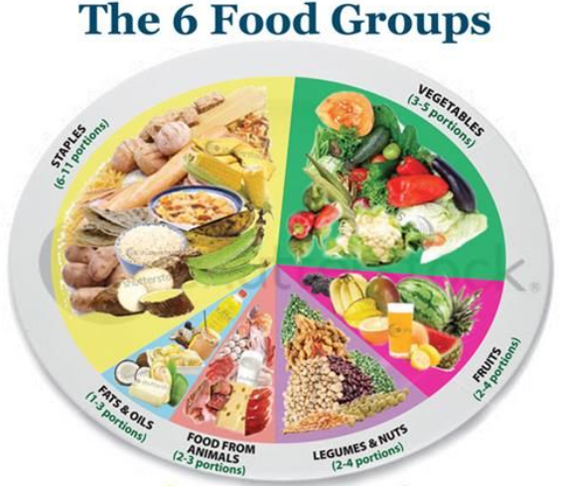  Assessment  1. (a) Explain the term food and state four (4) uses of food in the body.  (b) Copy the table and put the following food items under their appropriate groups.  (Bread, garden eggs, soya milk, yam, pineapple, cassava, plantain, pepper, oranges, eggs, onions, butter, beef, chicken, tomatoes, carrots, cucumber, sweet potatoes)  2. Explain how a balance diet can be prepared using the three (3) food groups.  3. (a) List four (4) food groups and give an example of food item in each group.  (b) Vitamin C can be easily destroyed. State four (4) ways of conserving vitamin C during food preparation.  4. (a) Group the six (6) food groups under the following headings.  i. Protective foods ii. Energy-giving foods iii. Body-building foods  (b) Mention two (two) importance of eating from each of the three (3) food groups daily.  5. Mention four characteristics of food |  |  |  |  | Pictures and charts of food
  Energy-giving foods | Protective foods | Body-building foods
PHASE 3: REFLECTION | Use peer discussion and effective questioning to find out from learners what they have learnt during the lesson.  Take feedback from learners and summarize the lesson.  Ask learners how the lesson will benefit them in their daily lives.

